I wrote a python program that the user will enter the Product ID and will show the price of the product.

In first run page the user will enter Usrename and Password

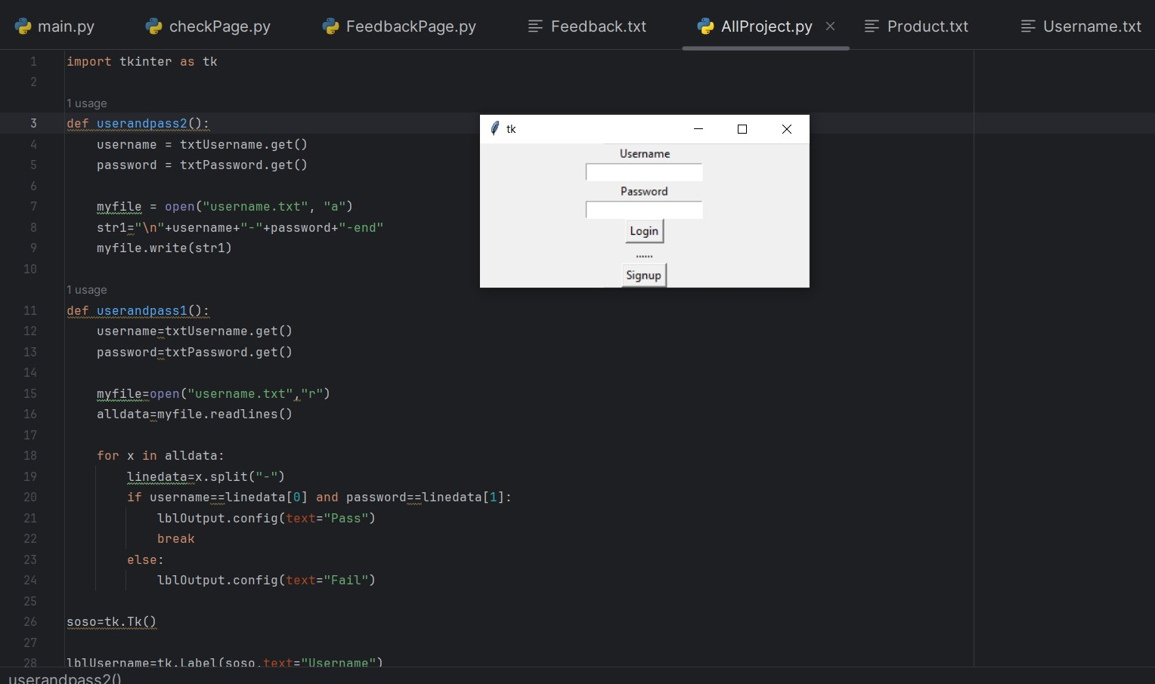

Second run page will show list of the product and the user will enter Product ID then will get the Price for the Product the user want

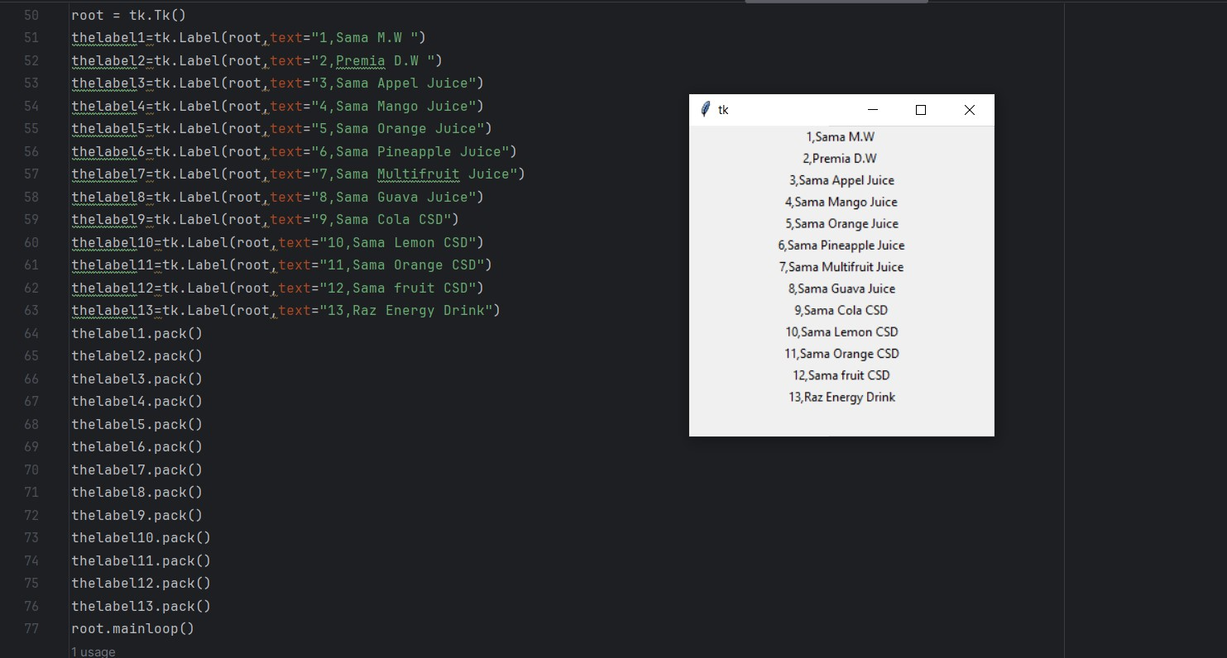

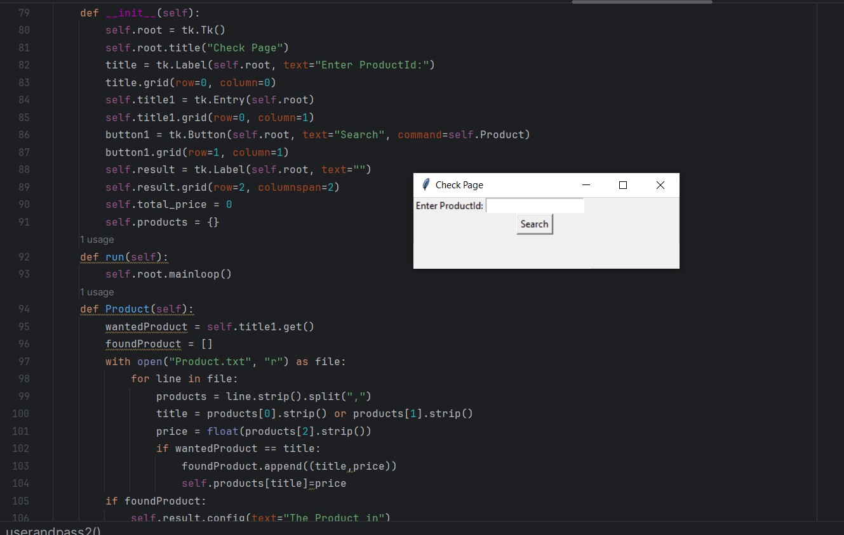

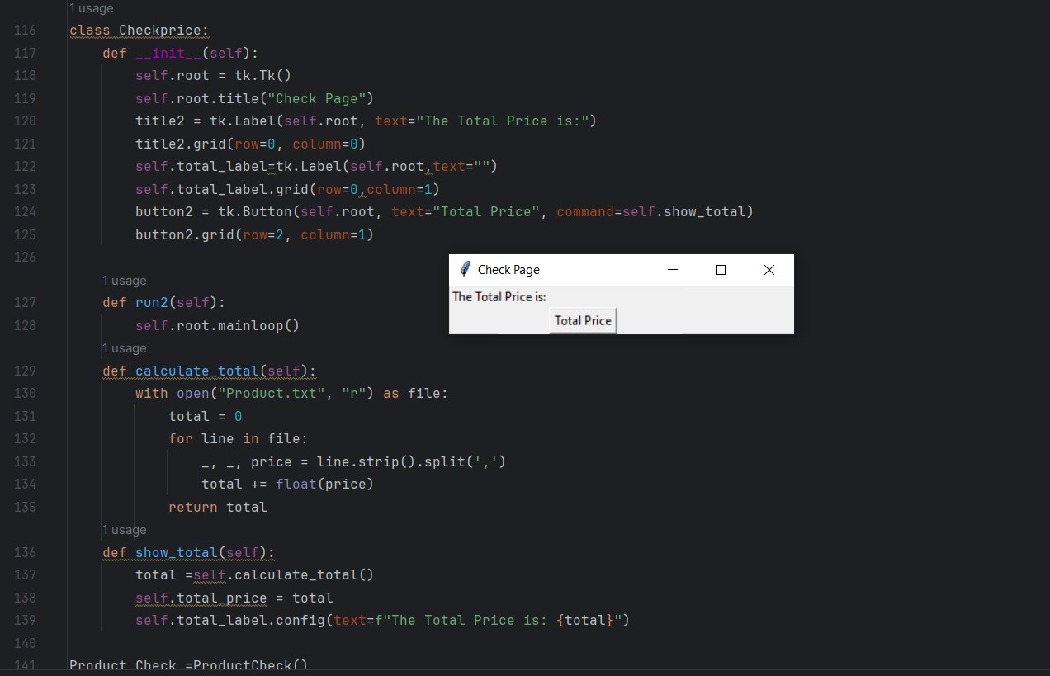

Third and finally the user will enter his feedback

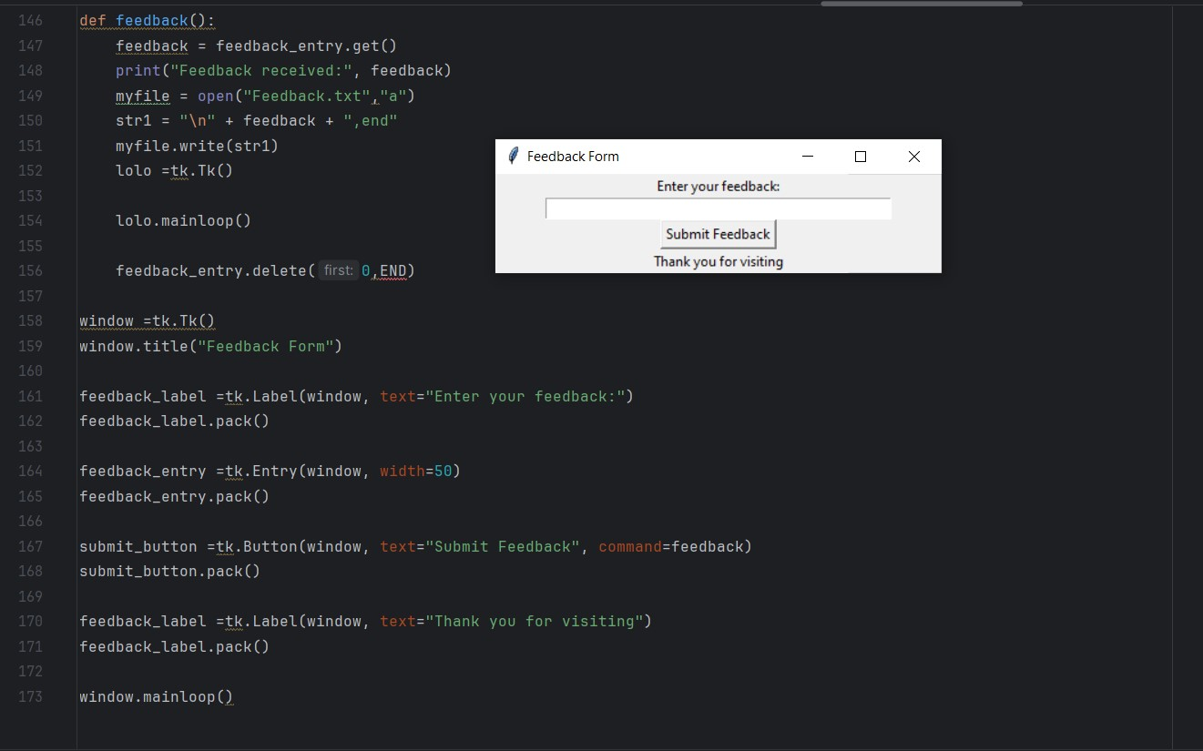

I Use in this program read and write from file and object-oriented programming and GUI interface (using tkinter) and list and loops and user-defined functions and many thing we took in the course